**Assignment – 10**

Name- Yashraj Ranjeet Shitole

Roll no. - 86633

1) Write a query that produces all pairs of salespeople who are living in the same city. Exclude combinations of salespeople with themselves as well as duplicate rows with the order reversed.

**select distinct a.sname, b.sname from salespeople a,salespeople b where a.city=b.city and a.sname>b.sname ;**

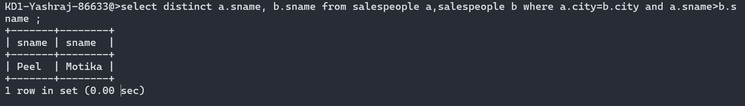

2) Write a query that produces the names and cities of all customers with the same rating as Hoffman.

**select cname, city from customers where rating=(select rating from customers where cname='Hoffman');**

